
QUALITY ALERT

Customer: ChamClad Date: January 25, 2024
Die: 15750 Color: TALC

Type of Complaint: ChamClad REJECT Customer NCR:
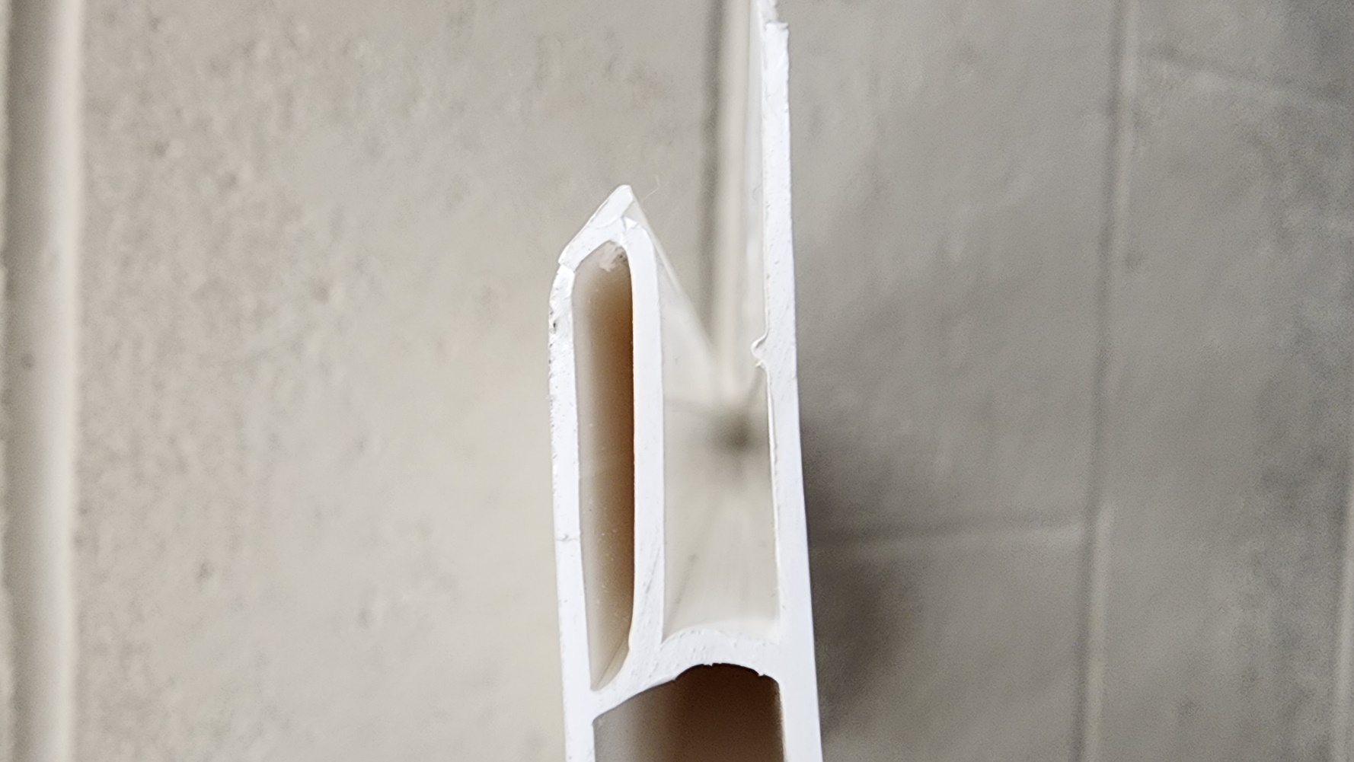
Description: ChamClad REJECT – Material was missing nip / the nip is too small.

GOOD

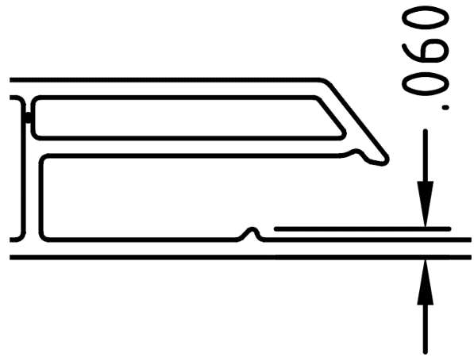
BAD

PLEASE CHECK CAREFULLY TO AVOID THIS ISSUE
BY SIGNING BELOW, YOU ACKNOWLEDGE THE PROBLEM ABOVE AND AGREE TO MONITOR THIS ISSUE IN FUTURE PRODUCTION RUNS.
DAY SHIFT |  | AFTERNOON SHIFT |  | NIGHT SHIFT
NAME | SIGNATURE | NAME | SIGNATURE | NAME | SIGNATURE

